4B OS Lab-04 Assignment

# CS182019 | Muhammad Danish

**CODE SCREENSHOTS:**

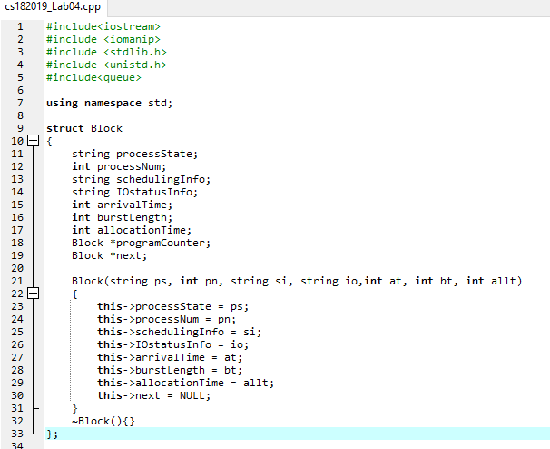

Continued………

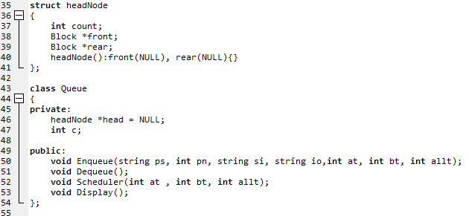

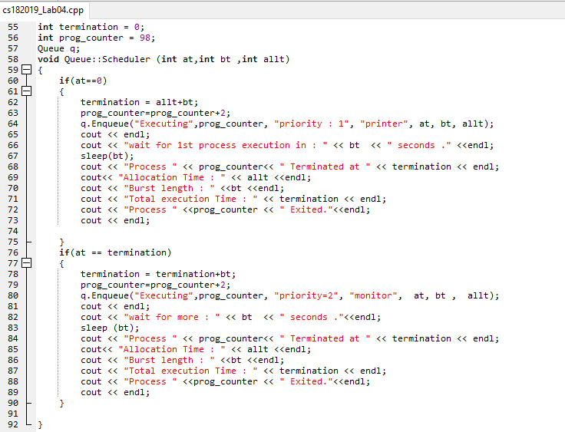

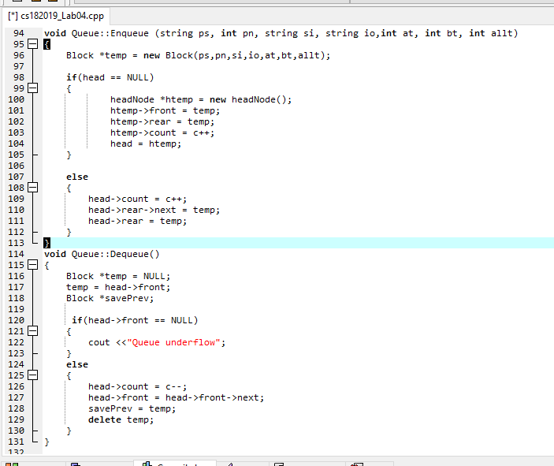

Continued………

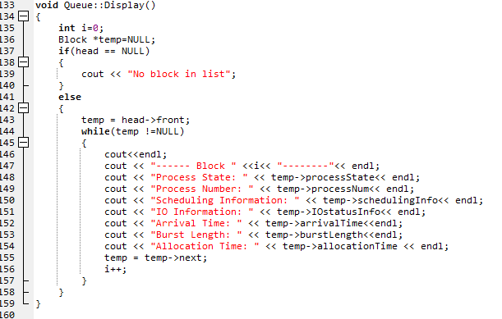

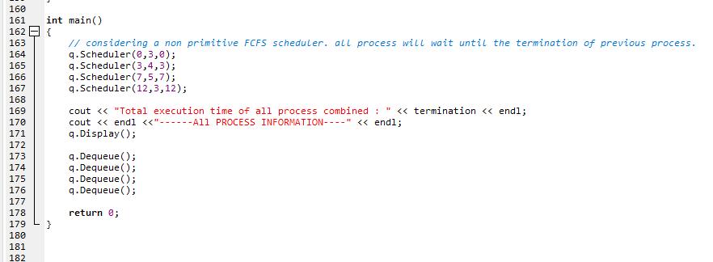

Continued………

**CODE OUTPUT SCREENSHOTS:**

Considering a non-primitive FCFS Scheduler, next program will wait until the execution of the previous program. When the process will Enqueue than Scheduler Function will wait(for seconds equal to burst time) for its execution.

Total execution time of all processes are calculated in between and printed at Last.

**Functions:** Sleep(till_burst_time) from system library is use to halt the program till the burst time of the process. Enqueing(Scheduling) of Processes is done inside Scheduler Function.

After total completion the block is Dequeue.

CS182019 | Muhammad Danish

